How to connect the OK Nozzle (below 100 L/min) to a pump

OK Engineering Co., Ltd.

1. Submersible pump

A. For 100 L/min OK Nozzle

1) Attach an elbow to the pump discharging side and set a straight part of 500-600 mm from there to the nozzle. This is to make the turbulence caused by the pump impeller as laminar as possible, and to prevent pressure loss due to the turbulence. The pipe length to make the flow laminar can be shorten by changing the flow from the pump at the elbow.

This is how you maximize the water pressure of the pump to be applied to the nozzle.

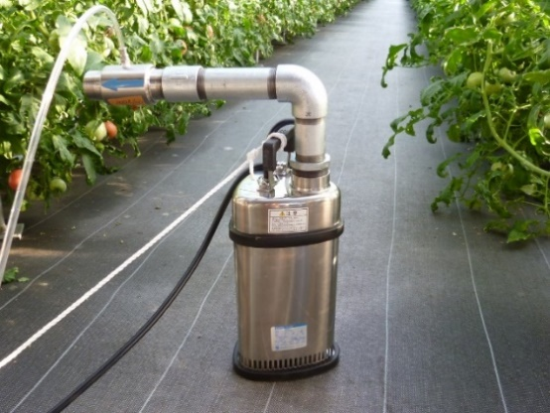2) If the installation becomes unstable due to the straight part for reducing the turbulence, fix the pump by providing support legs, etc.

3) If there is a lot of contaminants or sludge in the water, wrap the pump suction port with wire mesh to prevent the pump from sucking the contaminants. Perforated metal can be also used.

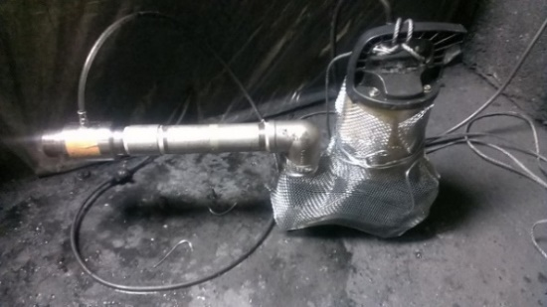

The example photos below are before and after using fine bubbles for the water tank of a painting booth.

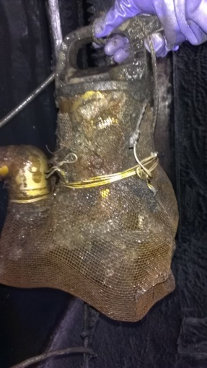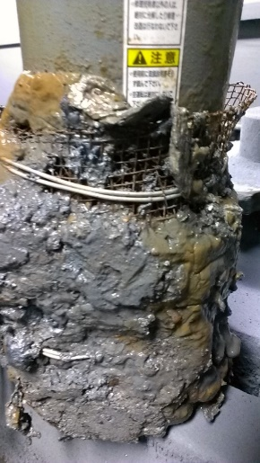

Without OK Nozzle & Fine bubbles With OK Nozzle and Fine bubbles

B. For 25 L/min OK Nozzle

1) When using pipes etc., attach elbow to the pump discharging side and provide straight part of 250 mm from there to the OK Nozzle. The reason of using elbow is the same as in the previous section: to shorten the pipe length to make the flow laminar.

2) When using vinyl hose, if the length of the hose is longer than 1 meter and the OK Nozzle is attached at the end, there should not be any problem.

C. For OK Nozzles below 25 L/min

Provide straight part of 100-150 mm always.

2. Land Pump

A. Basically the method of preventing the turbulence from the pump impeller is the same as the case of connecting OK Nozzle to a submersible pump. However, it should be noted that the piping OK Nozzle to land pumps is often more complicated than submersible pumps.

B.